Behavioral Segmentation for Targeted Marketing

Project Id: AIML-10

Name : Aditya Duuta
Class Roll Number:29
University Roll Number : 2028623
Section and Group: U(G1)

Name : Akash Kumar
Class Roll Number:30
University Roll Number : 2028629
Section and Group: U(G1)

Name : Himanshu Kumar
Class Roll Number : 14
University Roll Number:2028428
Section and Group: U(G1)

- Problem Description 3
- Architecture 4
- Models model 5
- Evaluation metrics used 6
- Preliminary Results and Visualizations 7
- References 8

- Problem Description
In today’s market, businesses need to understand their customers better to offer the right products and services. This project focuses on grouping customers based on their buying behavior using a machine learning technique called K-Means clustering. The aim is to identify different types of customers, also known as customer segments or personas.
Before applying the algorithm, the data is scaled using StandardScaler so that all features are treated equally and no single value dominates the results. The Elbow Method is then used to find the most suitable number of clusters for accurate segmentation.
By dividing customers into meaningful groups, businesses can create more targeted marketing strategies, improve customer experience, and increase overall sales. This type of analysis is commonly used in real-life scenarios such as online shopping platforms, retail businesses, and digital marketing systems, where understanding customer behavior plays a key role in decision-making.

2.Architecture
The system follows these steps:
- Data Collection / Synthesis
- Data Preprocessing (Scaling using StandardScaler)
- Apply K-Means Clustering
- Elbow Method (Find Optimal K)
- Cluster Assignment
- Visualization (Scatter Plot)
Flowchart Diagram:

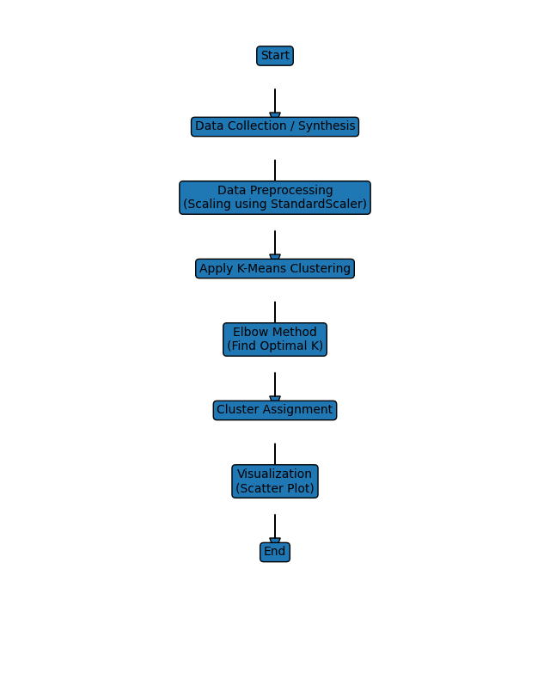

3.Models Used

K-Means Clustering
K-Means is an unsupervised machine learning algorithm used to group similar data points into clusters. It works by dividing the dataset into K distinct clusters, where each data point belongs to the cluster with the nearest mean (centroid).
Working Process:
- Select number of clusters (K)
- Initialize centroids randomly
- Assign data points to nearest centroid
- Update centroids based on cluster mean
- Repeat until convergence

4.Evaluation metrics

Silhouette Score = The Silhouette Score is an evaluation metric used to measure the quality of clustering in unsupervised learning algorithms like K-Means. It determines how well each data point fits within its assigned cluster compared to other clusters.

5. Preliminary Results and Visualizations
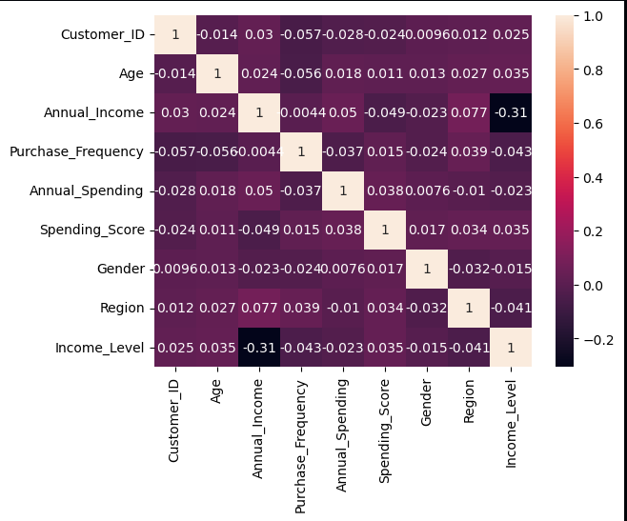

Fig.2 Heatmap showing corelation.

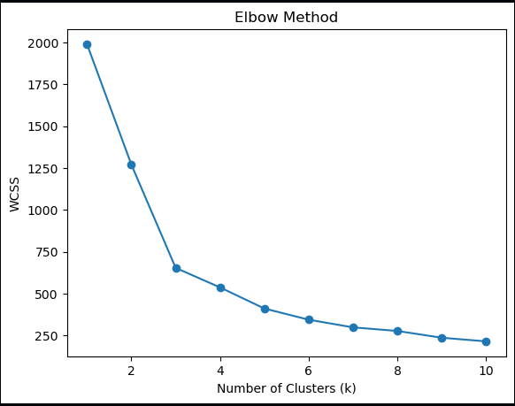
Fig.3- elbow method visualization to get k

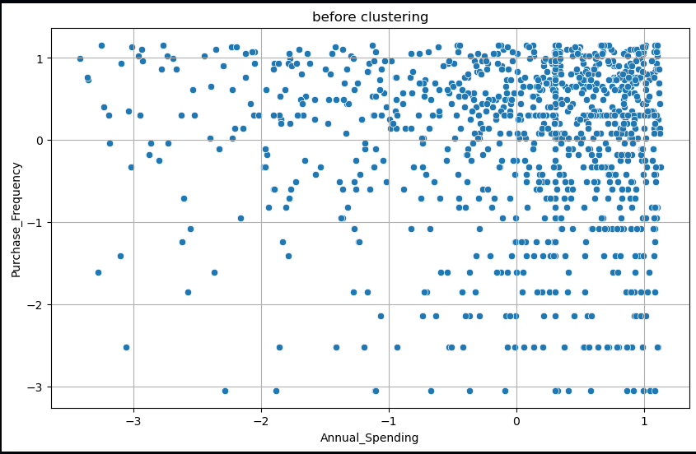
Fig 4-before clustering

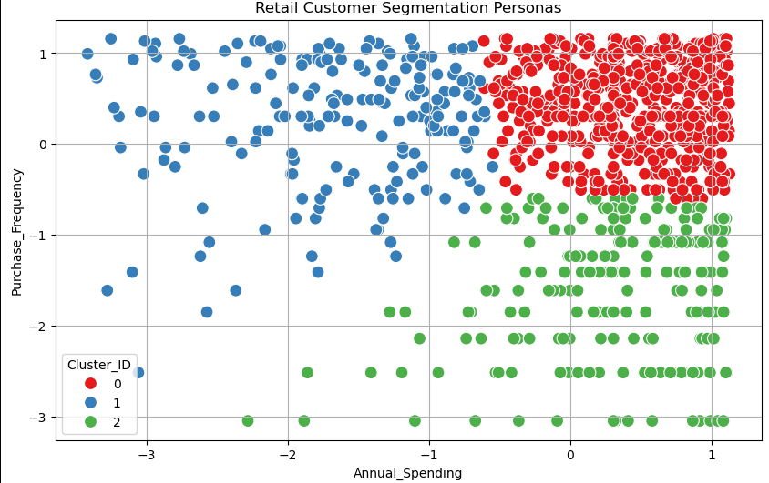
Fig5-After Clustering

Fig6-silhouette Score

6. References:
Books:
- Let Us Python – Yashavant Kanetkar

Online Resources:
  - GeeksforGeeks – https://www.geeksforgeeks.org/
  - TutorialsPoint – https://www.tutorialspoint.com/cprogramming/index.htm
  - Stack Overflow – https://stackoverflow.com

